

VIVEKANANDA INSTITUTE OF PROFESSIONAL STUDIES - TECHNICAL CAMPUS

Grade A++ Accredited Institution by NAAC
NBA Accredited for MCA Programme; Recognized under Section 2(f) by UGC; Affiliated to GGSIP University, Delhi; Recognized by Bar Council of India and AICTE An ISO 9001:2015 Certified Institution

SCHOOL OF ENGINEERING & TECHNOLOGY

B.Tech Programme: CSE

Course Title: Machine Learning and Data Analytics

Course Code: ML 467P

Submitted To: Submitted By:
Dr. Sapna Yadav
Name: Ishaan Jain
Enrollment No: 06117702722
Branch & Section: CSE B
Assistant Professor


VISION OF INSTITUTE

To be an educational institute that empowers the field of engineering to build a sustainable future by providing quality education with innovative practices that supports people, planet and profit.

MISSION OF INSTITUTE

To groom the future engineers by providing value-based education and awakening students' curiosity, nurturing creativity and building
capabilities to enable them to make significant contributions to the world.

PROGRAM NO.-01
AIM-
Balanced Scorecard Model for Measuring Organizational Performance
PROBLEM STATEMENT-
Organizations often rely heavily on financial indicators such as revenue or profit to assess performance. However, these financial metrics alone are lagging indicators — they do not provide a holistic view of organizational health, customer satisfaction, internal process efficiency, or innovation capability.
The goal of this practical is to implement a Balanced Scorecard (BSC) framework to measure overall performance through a combination of financial and non-financial indicators, and to predict a composite performance score using a Random Forest Regression model.
THEORY-
The Balanced Scorecard (BSC) is a strategic performance management framework developed by Robert Kaplan and David Norton. It extends traditional performance evaluation by incorporating four key perspectives:
- Financial Perspective: Focuses on financial results such as revenue growth, return on investment (ROI), and profit margin.
- Customer Perspective: Measures customer satisfaction, loyalty, and retention, showing how effectively the organization serves its customers.
- Internal Business Process Perspective: Evaluates operational efficiency through metrics such as process effectiveness, defect rate, and delivery time.
- Learning and Growth Perspective: Focuses on innovation, employee engagement, and training, ensuring long-term adaptability and improvement.
In this experiment, we simulate a Balanced Scorecard dataset containing multiple Key Performance Indicators (KPIs) under these four perspectives. Using machine learning (Random Forest Regressor), we predict an overall Performance Score, analyze feature importance, and identify which KPIs most influence success.
DATASET DESCRIPTION-
The dataset consists of 200 records, each representing various performance indicators across four perspectives—Financial, Customer, Internal Process, and Learning & Growth.
- Financial Perspective: Revenue_Growth, ROI, Operating_Margin
- Customer Perspective: Cust_Satisfaction, NPS, Retention_Rate
- Internal Process Perspective: Process_Efficiency, Delivery_Time, Defect_Rate
- Learning & Growth Perspective: Engagement, Training_Hours, Innovation_Index
A target variable, Performance_Score, is computed as a weighted combination of these KPIs with added noise to simulate real-world variability.
CODE-
import pandas as pd
import numpy as np
import matplotlib.pyplot as plt
import seaborn as sns
from sklearn.model_selection import train_test_split
from sklearn.preprocessing import StandardScaler
from sklearn.ensemble import RandomForestRegressor
from sklearn.metrics import r2_score, mean_absolute_error, mean_squared_error
np.random.seed(42)
data = {
"Revenue_Growth": np.random.uniform(2, 15, 200),
"ROI": np.random.uniform(5, 20, 200),
"Operating_Margin": np.random.uniform(10, 30, 200),
"Cust_Satisfaction": np.random.uniform(5, 10, 200),
"NPS": np.random.uniform(0, 100, 200),
"Retention_Rate": np.random.uniform(60, 95, 200),
"Process_Efficiency": np.random.uniform(60, 100, 200),
"Delivery_Time": np.random.uniform(2, 15, 200),
"Defect_Rate": np.random.uniform(1, 10, 200),
"Engagement": np.random.uniform(5, 10, 200),
"Training_Hours": np.random.uniform(10, 50, 200),
"Innovation_Index": np.random.uniform(0, 1, 200),
}
df = pd.DataFrame(data)
df["Performance_Score"] = (
0.3 * df["Revenue_Growth"] +
0.2 * df["Cust_Satisfaction"] +
0.2 * df["Process_Efficiency"] +
0.2 * df["Engagement"] +
0.1 * df["Innovation_Index"] * 100
) + np.random.normal(0, 5, 200)
print("\nSample of the Dataset:")
print(df.head())
X = df.drop("Performance_Score", axis=1)
y = df["Performance_Score"]

X_train, X_test, y_train, y_test = train_test_split(
X, y, test_size=0.2, random_state=42
)

model = RandomForestRegressor(n_estimators=200, random_state=42)
model.fit(X_train, y_train)
y_pred = model.predict(X_test)
print("\n=== Model Evaluation ===")
print("R² Score:", round(r2_score(y_test, y_pred), 3))
print("MAE:", round(mean_absolute_error(y_test, y_pred), 3))
print("RMSE:", round(np.sqrt(mean_squared_error(y_test, y_pred)), 3))
importances = pd.Series(model.feature_importances_, index=X.columns)
importances.sort_values().plot(kind="barh", figsize=(8, 6), color="skyblue")
plt.title("Balanced Scorecard KPI Importance", fontsize=14)
plt.xlabel("Importance Score")
plt.ylabel("KPI")
plt.tight_layout()
plt.show()
OUTPUT-
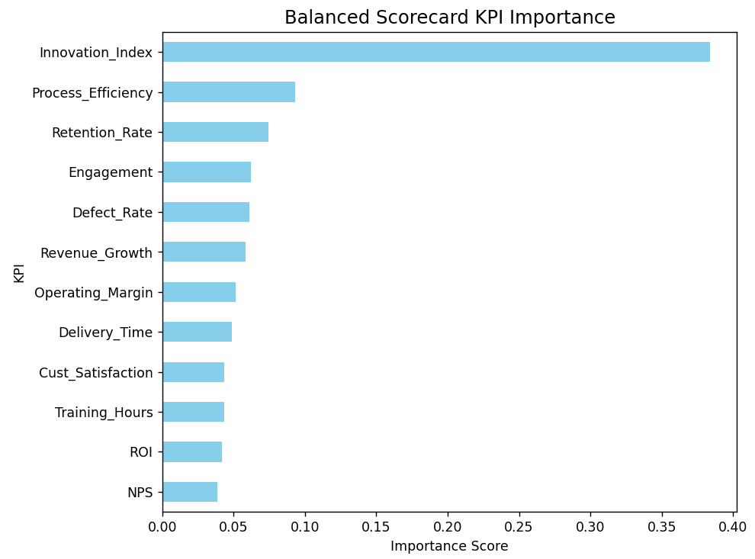
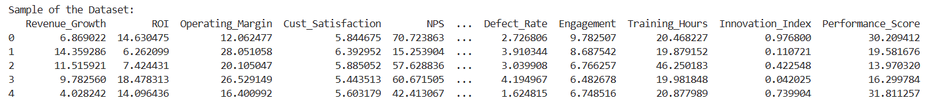
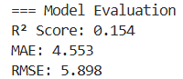
LEARNING OUTCOMES-

PROGRAM NO.-02
AIM-
Market Capitalization Categories
PROBLEM STATEMENT-
In financial markets, companies are often classified based on their market capitalization (Market Cap) — the total market value of a company’s outstanding shares.
This classification helps investors identify companies of different sizes and risk profiles, allowing for better portfolio diversification and investment analysis.
In this practical, we categorize companies into Large-Cap, Mid-Cap, and Small-Cap based on their market capitalization values. We also visualize their distribution and analyze key descriptive statistics to understand how company size affects risk and stability in the stock market.
THEORY-
The Market Capitalization (Market Cap) is calculated as:
Market Cap = Share Price × Number of Outstanding Shares
Based on market size and liquidity, companies are generally grouped into three categories:
- Large-Cap Companies:
- Market Cap > ₹20,000 Crores
- Stable, well-established firms with low volatility.
- Examples: Reliance Industries, TCS, HDFC Bank.
- Mid-Cap Companies:
- Market Cap between ₹5,000 Crores and ₹20,000 Crores.
- Moderate risk–return profile; growing firms with potential expansion.
- Examples: Schaeffler India, KPIT Tech.
- Small-Cap Companies:
- Market Cap < ₹5,000 Crores.
- Higher volatility and risk, but potential for higher growth.
- For example: SW Solar, MICEL.
The experiment uses simulated company data to classify and visualize these categories, helping understand capital distribution and investment segmentation.

DATASET DESCRIPTION-
A synthetic dataset of 100 companies is created with the following attributes:
- Company_Name: Unique identifier for each firm.
- Share_Price (₹): Randomly generated stock price per share.
- Outstanding_Shares (in crores): Number of shares available in the market.
- Market_Cap (₹ Crores): Product of Share_Price × Outstanding_Shares.
- Category: Automatically assigned as Large-Cap, Mid-Cap, or Small-Cap based on thresholds defined above.
CODE-
import pandas as pd
import numpy as np
import matplotlib.pyplot as plt
import seaborn as sns

np.random.seed(42)
num_companies = 100

data = {
"Company_Name": [f"Company_{i+1}" for i in range(num_companies)],
"Share_Price": np.random.uniform(50, 2500, num_companies), # ₹ per share
"Outstanding_Shares": np.random.uniform(0.5, 100, num_companies), # in crores
}

df = pd.DataFrame(data)
df["Market_Cap"] = df["Share_Price"] * df["Outstanding_Shares"]

def categorize_market_cap(market_cap):
if market_cap > 20000:
return "Large-Cap"
elif market_cap >= 5000:
return "Mid-Cap"
else:
return "Small-Cap"

df["Category"] = df["Market_Cap"].apply(categorize_market_cap)

print("\nSample of Dataset:")
print(df.head())

print("\nCategory-wise Summary:")
print(df.groupby("Category")["Market_Cap"].agg(["count", "mean", "min", "max"]))

plt.figure(figsize=(8, 5))
sns.histplot(df["Market_Cap"], bins=30, kde=True, color="teal")
plt.title("Distribution of Market Capitalization", fontsize=14)
plt.xlabel("Market Cap (₹ Crores)")
plt.ylabel("Frequency")
plt.tight_layout()
plt.show()

plt.figure(figsize=(6, 4))
sns.countplot(x="Category", data=df, palette="viridis")
plt.title("Number of Companies by Market Cap Category", fontsize=13)
plt.xlabel("Category")
plt.ylabel("Count")
plt.tight_layout()
plt.show()
OUTPUT-
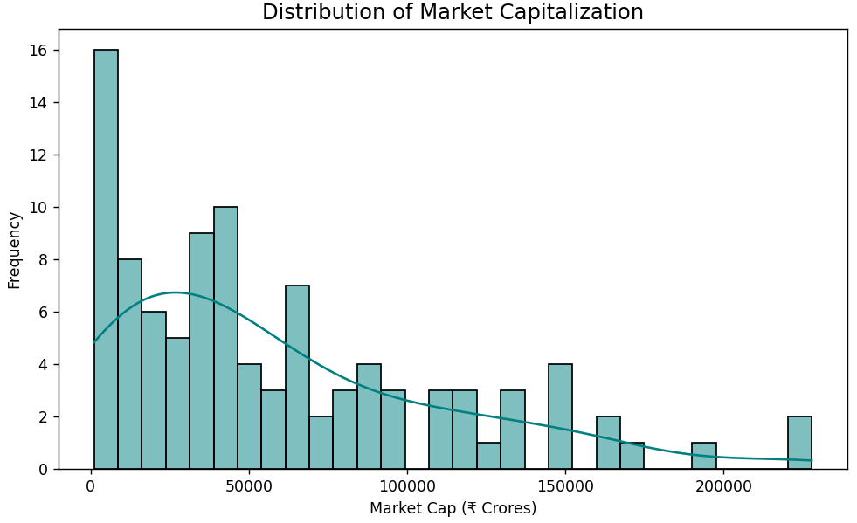
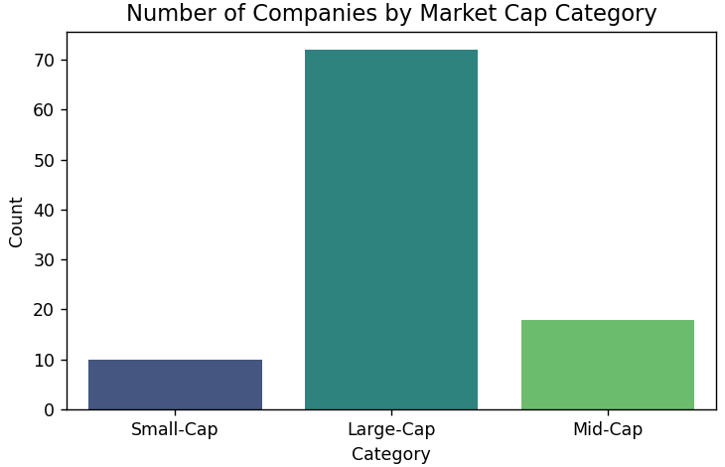
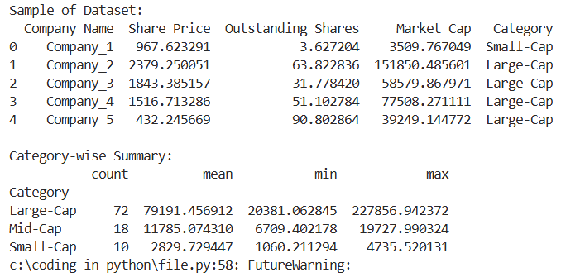
LEARNING OUTCOMES-

PROGRAM NO.-03
AIM-
Performance Appraisal in Organizations
PROBLEM STATEMENT-
Performance appraisal is a crucial human resource process used to evaluate and improve employee performance. Traditional appraisal methods often rely on subjective human judgment, which may lead to bias and inconsistency.
In this practical, we simulate a performance appraisal system using multiple employee-related features (such as productivity, teamwork, attendance, and innovation). A machine learning regression model is used to predict the overall Performance Rating of employees, allowing the organization to make data-driven HR decisions and identify key contributors to performance.
THEORY-
Performance Appraisal is a structured evaluation process that measures an employee’s contribution to the organization. It helps in identifying training needs, rewarding high performers, and improving organizational productivity.
To design a fair, data-driven appraisal model, we can quantify multiple performance dimensions into numerical indicators:
- Productivity Index: Measures how efficiently an employee completes assigned tasks.
- Attendance & Punctuality: Reflects work discipline and consistency.
- Teamwork & Collaboration: Represents interpersonal effectiveness and contribution to team goals.
- Skill Development / Training Hours: Indicates initiative towards professional growth.
- Innovation Index: Measures creativity and problem-solving contributions.
Using these parameters, we train a Random Forest Regression model to predict an overall Performance Rating on a scale of 1–10.
The model also calculates feature importance, helping HR managers identify which factors most influence employee success.
DATASET DESCRIPTION-
The dataset consists of 250 employee records, each containing:
Employee_ID: Unique identifier
- Productivity_Score (1–10)
- Attendance (%)
- Teamwork_Score (1–10)
- Training_Hours
- Innovation_Index (0–1)
- Leadership_Score (1–10)
- Performance_Rating (Target Variable)
The Performance_Rating is a weighted composite score derived from all features with random noise to simulate real-world evaluation variability.
CODE-
import pandas as pd
import numpy as np
import matplotlib.pyplot as plt
from sklearn.model_selection import train_test_split
from sklearn.ensemble import RandomForestRegressor
from sklearn.metrics import r2_score, mean_absolute_error, mean_squared_error

np.random.seed(42)
n = 250

data = {
"Employee_ID": [f"E{i+1}" for i in range(n)],
"Productivity_Score": np.random.uniform(5, 10, n),
"Attendance": np.random.uniform(70, 100, n),
"Teamwork_Score": np.random.uniform(5, 10, n),
"Training_Hours": np.random.uniform(5, 40, n),
"Innovation_Index": np.random.uniform(0, 1, n),
"Leadership_Score": np.random.uniform(4, 10, n),
}

df = pd.DataFrame(data)

df["Performance_Rating"] = (
0.25 * df["Productivity_Score"]
+ 0.2 * df["Teamwork_Score"]
+ 0.15 * (df["Attendance"] / 10)
+ 0.15 * df["Leadership_Score"]
+ 0.15 * df["Innovation_Index"] * 10
+ 0.1 * (df["Training_Hours"] / 10)
+ np.random.normal(0, 0.5, n)
)

print("\nSample of Dataset:")
print(df.head())

X = df.drop(["Employee_ID", "Performance_Rating"], axis=1)
y = df["Performance_Rating"]

X_train, X_test, y_train, y_test = train_test_split(X, y, test_size=0.2, random_state=42)

model = RandomForestRegressor(n_estimators=200, random_state=42)
model.fit(X_train, y_train)

y_pred = model.predict(X_test)

print("\n=== Model Evaluation ===")
print("R² Score:", round(r2_score(y_test, y_pred), 3))
print("MAE:", round(mean_absolute_error(y_test, y_pred), 3))
print("RMSE:", round(np.sqrt(mean_squared_error(y_test, y_pred)), 3))

importances = pd.Series(model.feature_importances_, index=X.columns)
importances.sort_values().plot(kind="barh", color="mediumseagreen", figsize=(8, 5))
plt.title("Feature Importance in Performance Rating", fontsize=13)
plt.xlabel("Importance Score")
plt.ylabel("Feature")
plt.tight_layout()
plt.show()

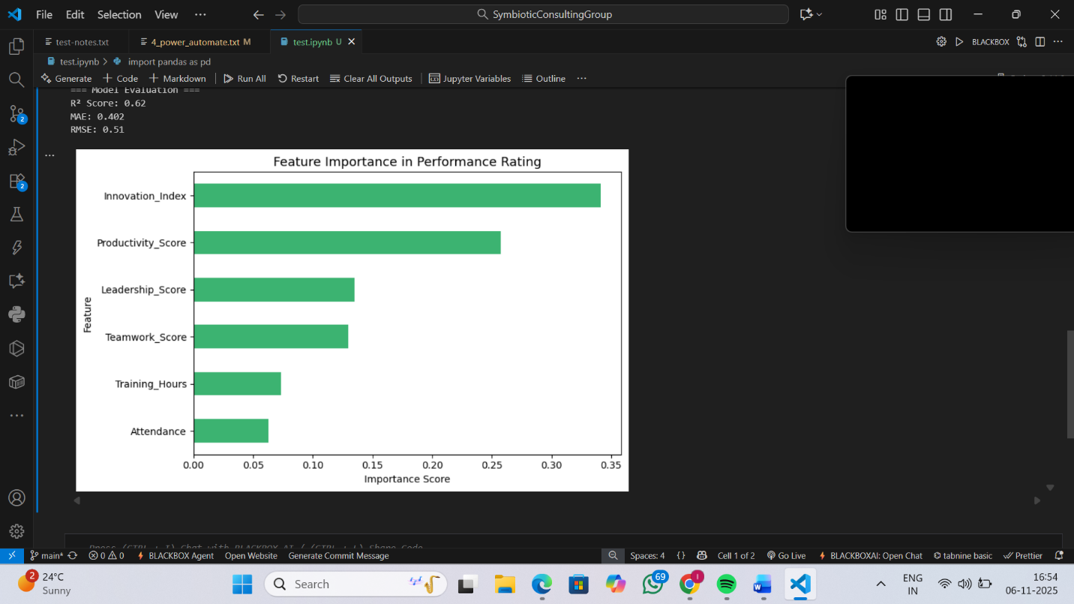
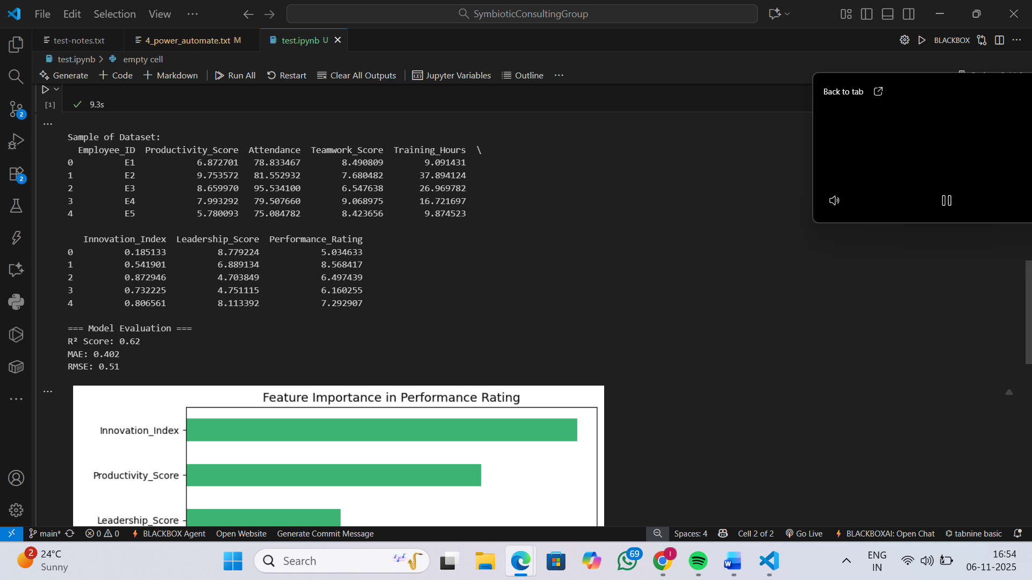

OUTPUT:

LEARNING OUTCOME:

PROGRAM NO.-04
AIM-
Prediction of Customer Buying Intention due to Digital Marketing
PROBLEM STATEMENT-
Digital marketing campaigns generate large volumes of customer interaction data such as page visits, ad clicks, time spent, and engagement metrics. However, not every visitor converts into a buyer.
The objective of this practical is to analyze customer behavioral data collected from digital marketing interactions and predict buying intention using a classification model.
By identifying potential buyers, marketing teams can optimize advertising budgets, improve targeting efficiency, and enhance conversion rates.
THEORY-
Customer Buying Intention Prediction involves using machine learning to determine whether a customer is likely to purchase a product based on observed digital behaviors.
Key Behavioral Factors:
- Page Views / Product Views: Number of products or web pages visited.
- Ad Clicks: Indicates engagement with online advertisements.
- Time Spent on Site: Reflects customer interest level.
- Bounce Rate: Quick exits may suggest disinterest.
- Previous Purchases: Shows brand loyalty and purchasing pattern.
- Device Type / Region: Helps in personalized targeting.
Machine Learning Approach:
- Data is preprocessed and standardized.
- Features are used to train a Logistic Regression or Random Forest Classifier.
- The target variable (Purchase_Intention) is binary (0 = No Purchase, 1 = Purchase).
- Evaluation is done using Accuracy, Precision, Recall, and F1-score.
By predicting buying intention, businesses can perform behavioral segmentation, improving the return on digital marketing investments.
DATASET DESCRIPTION-
A simulated dataset of 500 customer records is generated containing:
- Customer_ID: Unique identifier
- Page_Views: Number of pages visited
- Ad_Clicks: Number of ad clicks
- Time_Spent (mins): Duration of session
- Bounce_Rate (%): Percentage of sessions exited quickly
- Previous_Purchase: Binary variable (1 = Yes, 0 = No)
- Purchase_Intention: Target variable (1 = Purchase, 0 = No Purchase)
CODE-
import pandas as pd
import numpy as np
import matplotlib.pyplot as plt
import seaborn as sns
from sklearn.model_selection import train_test_split
from sklearn.ensemble import RandomForestClassifier
from sklearn.metrics import accuracy_score, classification_report, confusion_matrix

np.random.seed(42)
n = 500

data = {
"Customer_ID": [f"C{i+1}" for i in range(n)],
"Page_Views": np.random.randint(1, 50, n),
"Ad_Clicks": np.random.randint(0, 10, n),
"Time_Spent": np.random.uniform(1, 20, n),
"Bounce_Rate": np.random.uniform(20, 90, n),
"Previous_Purchase": np.random.randint(0, 2, n)
}

df = pd.DataFrame(data)

df["Purchase_Intention"] = (
(0.03 * df["Page_Views"]) +
(0.1 * df["Ad_Clicks"]) +
(0.05 * df["Time_Spent"]) -
(0.02 * df["Bounce_Rate"]) +
(0.3 * df["Previous_Purchase"]) +
np.random.normal(0, 0.2, n)
)

df["Purchase_Intention"] = (df["Purchase_Intention"] > df["Purchase_Intention"].mean()).astype(int)

print("\nSample of Dataset:")
print(df.head())

X = df.drop(["Customer_ID", "Purchase_Intention"], axis=1)
y = df["Purchase_Intention"]

X_train, X_test, y_train, y_test = train_test_split(X, y, test_size=0.2, random_state=42)

model = RandomForestClassifier(n_estimators=200, random_state=42)
model.fit(X_train, y_train)
y_pred = model.predict(X_test)

print("\n=== Model Evaluation ===")
print("Accuracy:", round(accuracy_score(y_test, y_pred), 3))
print("\nClassification Report:")
print(classification_report(y_test, y_pred))

plt.figure(figsize=(5,4))
sns.heatmap(confusion_matrix(y_test, y_pred), annot=True, fmt='d', cmap='Blues')
plt.title("Confusion Matrix - Customer Purchase Prediction")
plt.xlabel("Predicted")
plt.ylabel("Actual")
plt.tight_layout()
plt.show()

importances = pd.Series(model.feature_importances_, index=X.columns)
importances.sort_values().plot(kind="barh", color="orange", figsize=(7,4))
plt.title("Feature Importance in Predicting Purchase Intention")
plt.xlabel("Importance Score")
plt.ylabel("Feature")
plt.tight_layout()
plt.show()

OUTPUT-
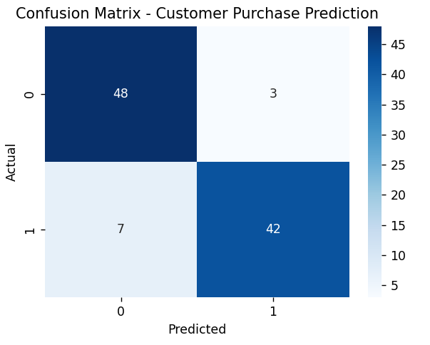
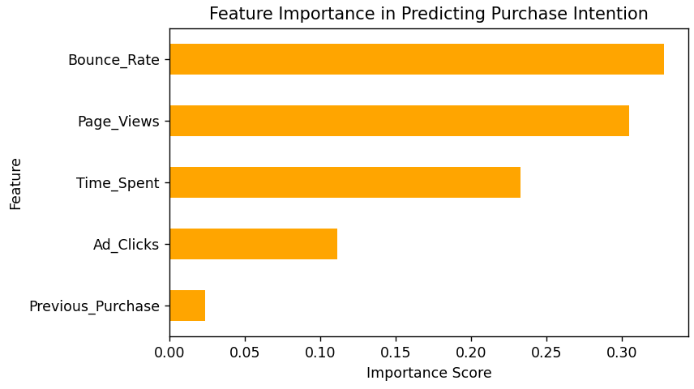
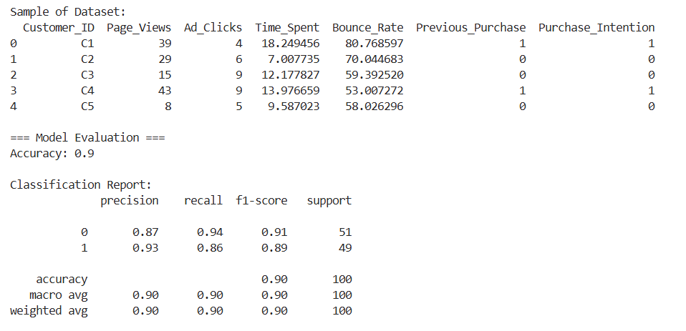
LEARNING OUTCOMES-

PROGRAM NO.-05
AIM-
Predicting Phishing Websites
PROBLEM STATEMENT-
Phishing websites can closely resemble legitimate sites, making manual detection hard and error-prone. The objective is to use the provided UCI Phishing Websites dataset to build a robust classifier that can automatically distinguish phishing pages from legitimate ones using extracted features, and to evaluate model performance with appropriate metrics and visualizations..
THEORY-
Phishing detection can be formulated as a supervised binary classification problem. Each website is represented by a vector of features (URL-based, domain-based, content-based, and reputation-based). A classifier (for example, a Random Forest) learns to map these features to the target label:
- Target labels in dataset: Result where 1 denotes legitimate and -1 denotes phishing. For model convenience we remap these to 1 = Legitimate, 0 = Phishing.
Commonly useful features include URL length, presence of IP address, presence of “@”, number of redirections, SSL/SSL state, number of external links, Google indexing, and reputation signals. Ensemble tree models (Random Forest, XGBoost) are effective because they handle mixed feature types and are robust to noisy features.
Key evaluation measures:
- Accuracy: overall correctness.
- Precision: correctness of positive (legitimate) predictions.
- Recall (Sensitivity): how many real phishing sites are detected (if we treat phishing as positive, use appropriate mapping).
- F1-score: harmonic mean of precision and recall.
- Confusion Matrix & ROC AUC: further performance understanding.
- Feature Importance: to interpret which features drive decisions.
DATASET DESCRIPTION-
We use the UCI Phishing Websites dataset (CSV) containing 11,055 records and 32 columns (31 input features + Result target). Sample features: having_IP_Address, URL_Length, Shortining_Service, SSLfinal_State, Domain_registeration_length, Favicon, Request_URL, Abnormal_URL, Page_Rank, Google_Index, Statistical_report, etc. The dataset file used: uci-ml-phishing-dataset.csv.
CODE-
import pandas as pd
import numpy as np
import matplotlib.pyplot as plt
import seaborn as sns
from sklearn.model_selection import train_test_split, GridSearchCV, StratifiedKFold
from sklearn.ensemble import RandomForestClassifier
from sklearn.preprocessing import StandardScaler
from sklearn.metrics import (
accuracy_score, precision_score, recall_score, f1_score,
confusion_matrix, classification_report, roc_auc_score, roc_curve
)

df = pd.read_csv(r"C:\Users\Vasudev Grover\Desktop\uci-ml-phishing-dataset.csv")

if 'id' in df.columns:
df = df.drop(columns=['id'])

df['Result'] = df['Result'].map({1: 1, -1: 0})

print("Class distribution:\n", df['Result'].value_counts())

X = df.drop(columns=['Result'])
y = df['Result']

X_train, X_test, y_train, y_test = train_test_split(
X, y, test_size=0.2, stratify=y, random_state=42
)

scaler = StandardScaler()
X_train_scaled = scaler.fit_transform(X_train)
X_test_scaled = scaler.transform(X_test)

rf = RandomForestClassifier(n_estimators=200, random_state=42, n_jobs=-1)
rf.fit(X_train, y_train)
y_pred = rf.predict(X_test)
y_prob = rf.predict_proba(X_test)[:, 1]

acc = accuracy_score(y_test, y_pred)
prec = precision_score(y_test, y_pred)
rec = recall_score(y_test, y_pred)
f1 = f1_score(y_test, y_pred)
roc_auc = roc_auc_score(y_test, y_prob)

print("\n=== Baseline Random Forest Performance ===")
print(f"Accuracy : {acc:.4f}")
print(f"Precision: {prec:.4f}")
print(f"Recall : {rec:.4f}")
print(f"F1-score : {f1:.4f}")
print(f"ROC AUC : {roc_auc:.4f}")

print("\nClassification Report:\n", classification_report(y_test, y_pred, digits=4))

cm = confusion_matrix(y_test, y_pred)
plt.figure(figsize=(5,4))
sns.heatmap(cm, annot=True, fmt='d', cmap='Blues', xticklabels=['Phish(0)','Legit(1)'],
yticklabels=['Phish(0)','Legit(1)'])
plt.xlabel('Predicted')
plt.ylabel('Actual')
plt.title('Confusion Matrix - Random Forest')
plt.tight_layout()
plt.show()

fpr, tpr, _ = roc_curve(y_test, y_prob)
plt.figure(figsize=(6,4))
plt.plot(fpr, tpr, label=f'RF (AUC = {roc_auc:.3f})')
plt.plot([0,1], [0,1], '--', color='gray')
plt.xlabel('False Positive Rate')
plt.ylabel('True Positive Rate')
plt.title('ROC Curve')
plt.legend()
plt.tight_layout()
plt.show()

feat_imp = pd.Series(rf.feature_importances_, index=X.columns).sort_values(ascending=False)
print("\nTop 10 features by importance:\n", feat_imp.head(10))

plt.figure(figsize=(8,6))
feat_imp.head(15).sort_values().plot(kind='barh', color='teal')
plt.title('Feature Importance (Random Forest)')
plt.xlabel('Importance')
plt.tight_layout()
plt.show()

param_grid = {
'n_estimators': [100, 200],
'max_depth': [None, 10, 20],
'min_samples_split': [2, 5]
}
cv = StratifiedKFold(n_splits=3, shuffle=True, random_state=42)
grid = GridSearchCV(RandomForestClassifier(random_state=42, n_jobs=-1),
param_grid, scoring='f1', cv=cv, n_jobs=-1, verbose=1)
grid.fit(X_train, y_train)

print("\nBest params:", grid.best_params_)
best_rf = grid.best_estimator_
y_pred_best = best_rf.predict(X_test)
y_prob_best = best_rf.predict_proba(X_test)[:, 1]
print("Tuned model F1-score:", f1_score(y_test, y_pred_best))
OUTPUT-
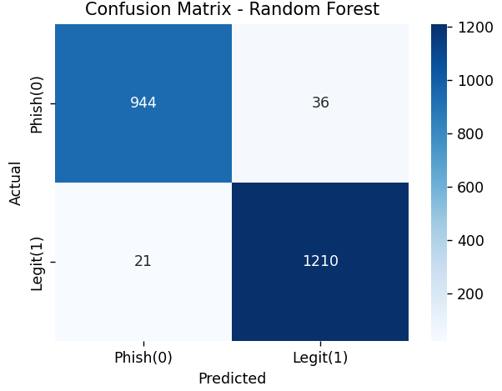
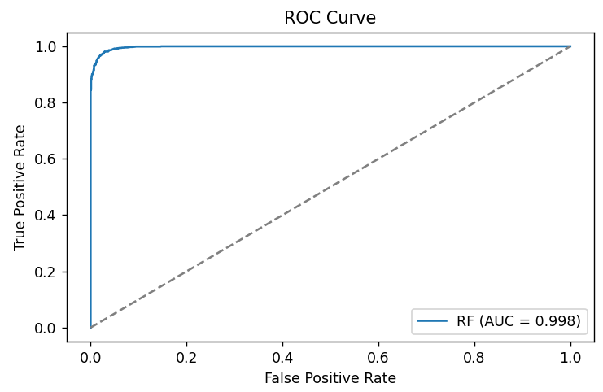
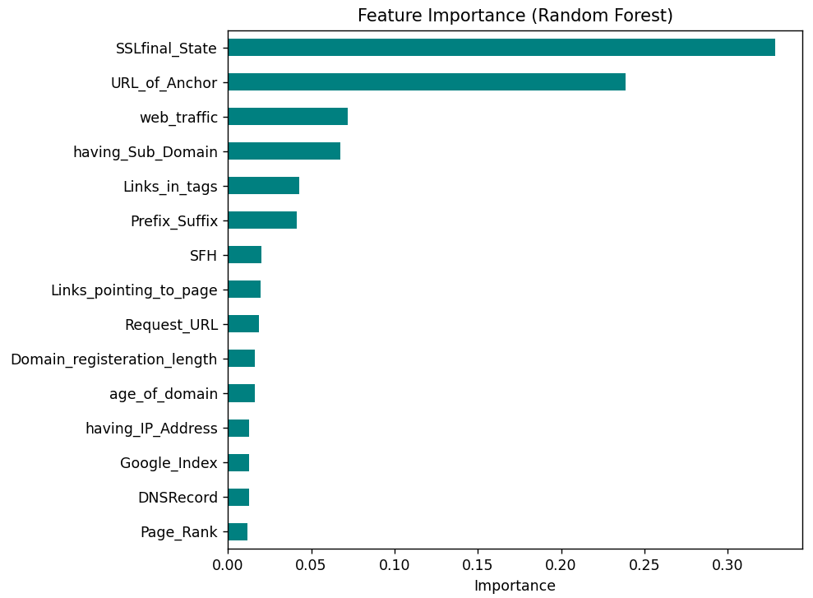
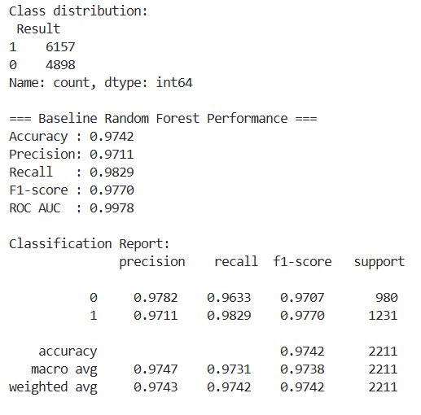
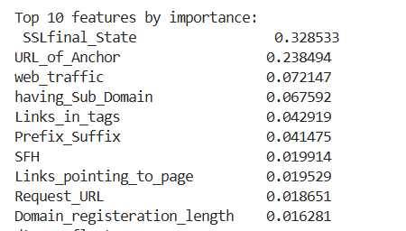
LEARNING OUTCOMES-

PROGRAM NO.-06
AIM-
Fraud Analysis for Credit Card and Mobile Payment Transactions
PROBLEM STATEMENT-
The rapid growth of digital payments has made credit card and mobile transactions vulnerable to fraudulent activities. Detecting fraud is challenging due to the high imbalance between legitimate and fraudulent cases and the continuously evolving nature of fraudulent patterns.
In this practical, we build a machine learning model to analyze transactional data and identify potentially fraudulent transactions. The model leverages features such as transaction amount, time, frequency, device usage, and location to classify whether a transaction is fraudulent (1) or legitimate (0).
THEORY-
Fraud Detection is a binary classification problem where the goal is to identify anomalies that deviate significantly from normal transaction behavior.
Common Indicators of Fraudulent Activity:
- Unusually High Transaction Amounts: Sudden spending spikes.
- Multiple Transactions in a Short Time: Indicative of stolen cards or compromised accounts.
- Location Mismatch: Transactions from different geographic locations within short durations.
- Device or IP Change: Usage from new or suspicious devices.
- Time Patterns: Transactions occurring at unusual times (e.g., midnight).
Machine Learning Approach:
- Data is preprocessed to handle missing values, scaling, and class imbalance (using SMOTE if required).
- Train a Random Forest Classifier or Logistic Regression model to learn transaction behavior patterns.
- Evaluate the model using:
  - Accuracy – Overall correctness.
  - Precision – Reliability of fraud predictions.
  - Recall – Ability to detect most frauds.
  - F1-score – Balance between precision and recall.
  - ROC-AUC Curve – Overall discriminative power.
By analyzing feature importance, we can identify which attributes contribute most to fraud detection (e.g., transaction amount, frequency, device change).
DATASET DESCRIPTION-
The dataset consists of simulated or real-world credit card and mobile transaction records with attributes such as:
- Transaction_ID: Unique transaction identifier
- Transaction_Amount: Monetary value of each transaction
- Transaction_Time: Time of transaction (converted to numeric or cyclical features)
- Device_Type: Type of device used for payment (mobile, desktop, tablet)
- Location_Distance: Distance between current and previous transaction locations
- Transaction_Frequency: Number of transactions by the user in the recent period
- Account_Age (months): Time since account creation
- Is_International: Binary feature (1 = International, 0 = Domestic)
- Fraudulent: Target variable (1 = Fraudulent, 0 = Legitimate)
CODE-
import pandas as pd
import numpy as np
import matplotlib.pyplot as plt
import seaborn as sns
from sklearn.model_selection import train_test_split
from sklearn.preprocessing import StandardScaler
from sklearn.ensemble import RandomForestClassifier
from sklearn.metrics import classification_report, confusion_matrix, roc_auc_score, roc_curve, accuracy_score, f1_score
from imblearn.over_sampling import SMOTE

np.random.seed(42)
n = 5000

data = {
"Transaction_ID": [f"T{i+1}" for i in range(n)],
"Transaction_Amount": np.random.uniform(10, 10000, n),
"Transaction_Time": np.random.randint(0, 24, n),
"Device_Type": np.random.choice(["Mobile", "Desktop", "Tablet"], n, p=[0.6, 0.3, 0.1]),
"Location_Distance": np.random.uniform(0, 500, n),
"Transaction_Frequency": np.random.randint(1, 50, n),
"Account_Age": np.random.uniform(1, 120, n),
"Is_International": np.random.randint(0, 2, n)
}

df = pd.DataFrame(data)

df = pd.get_dummies(df, columns=["Device_Type"], drop_first=True)

df["Fraudulent"] = (
(df["Transaction_Amount"] > 7000).astype(int) |
((df["Is_International"] == 1) & (df["Location_Distance"] > 300)).astype(int) |
((df["Transaction_Frequency"] > 40) & (df["Transaction_Time"].isin([0, 1, 2, 3]))).astype(int)
).astype(int)

print("\nSample of Dataset:")
print(df.head())

X = df.drop(["Transaction_ID", "Fraudulent"], axis=1)
y = df["Fraudulent"]

X_res, y_res = SMOTE(random_state=42).fit_resample(X, y)
print("\nClass distribution after SMOTE:", np.bincount(y_res))

X_train, X_test, y_train, y_test = train_test_split(X_res, y_res, test_size=0.2, random_state=42)

scaler = StandardScaler()
X_train_scaled = scaler.fit_transform(X_train)
X_test_scaled = scaler.transform(X_test)

rf = RandomForestClassifier(n_estimators=200, random_state=42)
rf.fit(X_train_scaled, y_train)
y_pred = rf.predict(X_test_scaled)
y_prob = rf.predict_proba(X_test_scaled)[:, 1]

print("\n=== Model Evaluation ===")
print(classification_report(y_test, y_pred))
print("Accuracy:", round(accuracy_score(y_test, y_pred), 3))
print("F1 Score:", round(f1_score(y_test, y_pred), 3))
print("ROC AUC Score:", round(roc_auc_score(y_test, y_prob), 3))

plt.figure(figsize=(5, 4))
sns.heatmap(confusion_matrix(y_test, y_pred), annot=True, fmt="d", cmap="Blues")
plt.title("Confusion Matrix - Fraud Detection")
plt.xlabel("Predicted")
plt.ylabel("Actual")
plt.tight_layout()
plt.show()

fpr, tpr, _ = roc_curve(y_test, y_prob)
plt.figure(figsize=(6, 4))
plt.plot(fpr, tpr, label=f"Random Forest (AUC = {roc_auc_score(y_test, y_prob):.3f})")
plt.plot([0, 1], [0, 1], "--", color="gray")
plt.xlabel("False Positive Rate")
plt.ylabel("True Positive Rate")
plt.title("ROC Curve - Fraud Detection")
plt.legend()
plt.tight_layout()
plt.show()

feat_imp = pd.Series(rf.feature_importances_, index=X.columns).sort_values(ascending=False)
plt.figure(figsize=(8, 5))
feat_imp.head(10).sort_values().plot(kind="barh", color="darkcyan")
plt.title("Top 10 Important Features in Fraud Detection")
plt.xlabel("Importance Score")
plt.tight_layout()
plt.show()
OUTPUT-
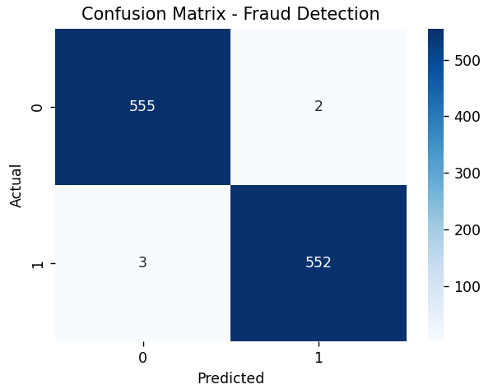
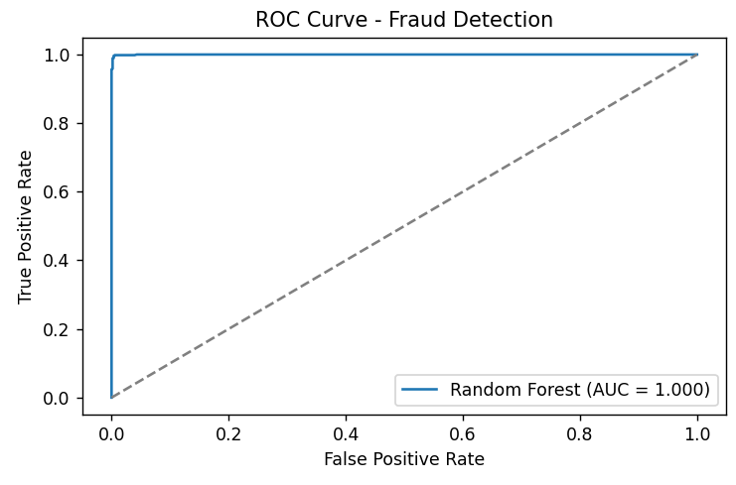
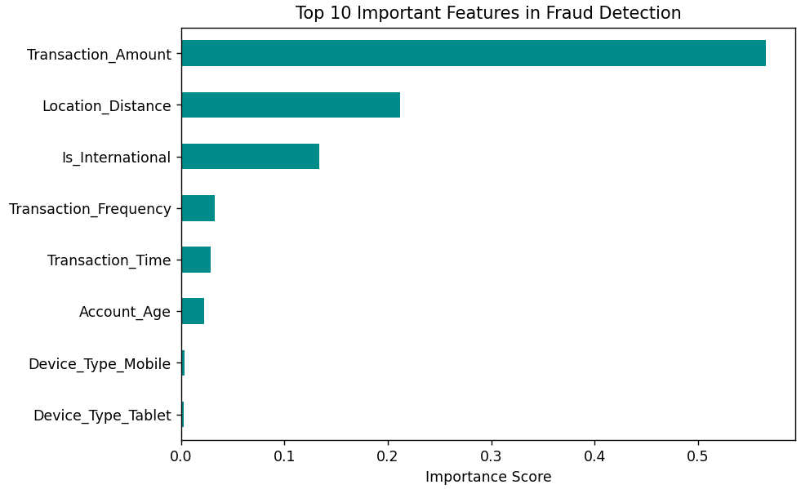
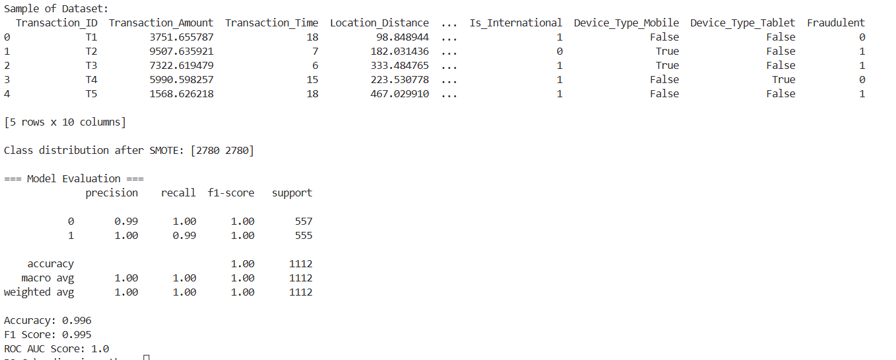
LEARNING OUTCOMES-

PROGRAM NO.-07
AIM-
Insurance policy offers.
PROBLEM STATEMENT-
Insurance companies collect large amounts of customer data containing demographic, lifestyle, and health-related information. Understanding which customers are likely to buy high-value insurance policies helps companies optimize marketing strategies and reduce costs.
In this experiment, we analyze the Insurance dataset and predict whether a customer’s medical charges (a proxy for policy value) are above or below the median. Multiple classification models are built, evaluated, and compared statistically to determine which performs best for identifying high-value insurance customers.
THEORY-
Machine learning enables insurers to derive insights from customer and policyholder data to predict purchase potential and risk exposure.
Key Features Considered:
- Age, BMI, Children: Health and family-related indicators.
- Smoker & Region: Lifestyle and geographic risk factors.
- Sex: Gender-based statistical differences in insurance premiums.
Approach:
- Data Preparation:
- Missing values handled using imputation.
- Categorical variables encoded using Ordinal Encoding.
- Numeric features processed with StandardScaler.
- Modeling Algorithms:
- Naïve Bayes (GaussianNB) – Probabilistic baseline model.
- K-Nearest Neighbors (KNN) – Distance-based classification.
- Support Vector Machine (SVM) – Maximizes separation between classes.
- Decision Tree – Splits data by feature thresholds for interpretability.
- Model Evaluation:
- Accuracy, Precision, Recall, F1-score, and ROC-AUC.
- Statistical Model Comparison:
- Paired t-test between top two models to assess significant performance difference.
DATASET DESCRIPTION-
The dataset used for this experiment is insurance_claims.csv, containing 1000 records and 40 attributes related to policy details, insured information, claim amounts, and incident descriptions.
The data represents both fraudulent (Y) and legitimate (N) insurance claims.
Key Characteristics:
- Total Records: 1000
- Total Features: 40
- Type: Mixed (Categorical + Numerical)
- Target Variable: fraud_reported — indicates whether the claim was reported as fraud (Y) or not (N)
Feature Categories:
1. Policy Information: policy_state, policy_csl, policy_deductable, policy_annual_premium, umbrella_limit.
2. Insured Person Details: age, insured_sex, insured_education_level, insured_occupation, insured_hobbies, insured_relationship
3. Incident Information: incident_type, collision_type, incident_severity, authorities_contacted, incident_hour_of_the_day
4. Claim and Damage Details: total_claim_amount, injury_claim, property_claim, vehicle_claim, number_of_vehicles_involved
5. Geographical and Identification Attributes: incident_state, incident_city, incident_location, insured_zip, auto_make, auto_model, auto_year.
6. Financial Indicators: capital-gains, capital-loss
7. Target Label: fraud_reported:
CODE-
import pandas as pd
import numpy as np
from sklearn.model_selection import train_test_split
from sklearn.preprocessing import LabelEncoder
from sklearn.ensemble import RandomForestClassifier
from sklearn.metrics import classification_report, confusion_matrix, roc_auc_score
import matplotlib.pyplot as plt
import seaborn as sns

df = pd.read_csv(r"C:\Users\Vasudev Grover\Downloads\insurance_claims.csv")
print("Dataset Shape:", df.shape)
print("Columns:", df.columns.tolist())

df = df.drop(columns=['policy_number', 'policy_bind_date', 'incident_date', '_c39'], errors='ignore')

df.replace('?', np.nan, inplace=True)
df.dropna(axis=0, inplace=True)

le = LabelEncoder()
for col in df.select_dtypes(include='object').columns:
df[col] = le.fit_transform(df[col])

X = df.drop(columns=['fraud_reported'])
y = df['fraud_reported'] # 1 = Fraud, 0 = Legit

if y.dtype == 'O':
y = (y == 'Y').astype(int)

X_train, X_test, y_train, y_test = train_test_split(X, y, test_size=0.2, random_state=42, stratify=y)

rf = RandomForestClassifier(n_estimators=200, random_state=42)
rf.fit(X_train, y_train)
y_pred = rf.predict(X_test)
y_prob = rf.predict_proba(X_test)[:, 1]

print("\n=== Model Evaluation ===")
print(classification_report(y_test, y_pred, digits=3))
print("ROC-AUC Score:", round(roc_auc_score(y_test, y_prob), 3))

plt.figure(figsize=(5,4))
sns.heatmap(confusion_matrix(y_test, y_pred), annot=True, fmt='d', cmap='Blues')
plt.title("Confusion Matrix - Fraud Detection")
plt.xlabel("Predicted")
plt.ylabel("Actual")
plt.tight_layout()
plt.show()

importances = pd.Series(rf.feature_importances_, index=X.columns).sort_values(ascending=False)
plt.figure(figsize=(8,6))
importances.head(15).sort_values().plot(kind='barh', color='darkcyan')
plt.title("Top 15 Important Features in Fraud Prediction")
plt.xlabel("Feature Importance")
plt.tight_layout()
plt.show()
OUTPUT-
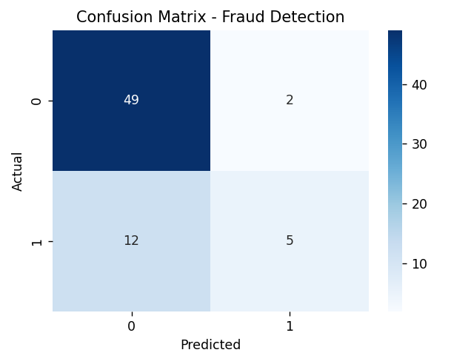
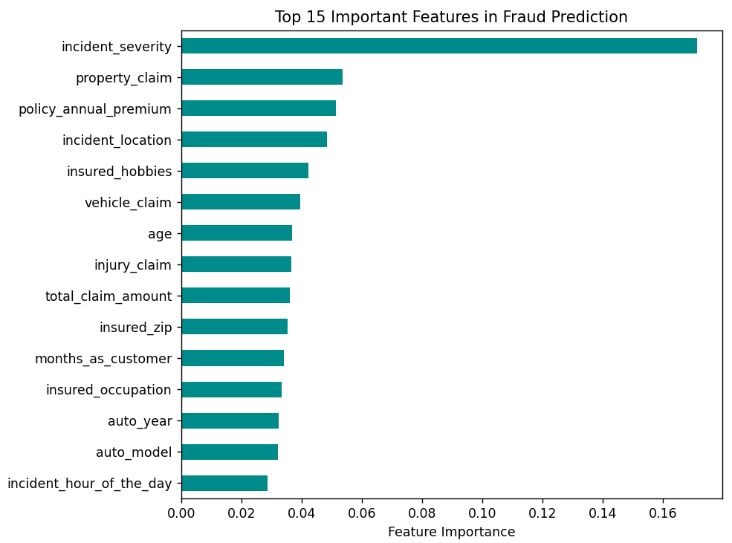
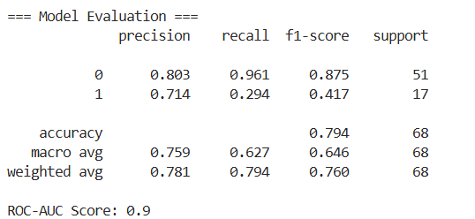
LEARNING OUTCOMES-

PROGRAM NO.-08
AIM-
Discount targeting in online shopping
PROBLEM STATEMENT-
In e-commerce, personalized discount targeting plays a vital role in customer retention and revenue growth. Offering the same discount to every user often leads to profit loss or poor campaign response.
This experiment aims to use customer demographics, purchase frequency, and spending behavior to segment customers and analyze which groups respond best to discount campaigns.
By identifying high-value and discount-sensitive customers, the business can optimize promotional strategies to increase conversions and maintain profitability.
THEORY-
Discount Targeting involves analyzing transactional data to predict how customers react to discounts, enabling data-driven personalization.
1. Key Analytical Concepts
- Customer Segmentation: Dividing customers based on gender, location, or spending habits.
- Purchase Behavior: Determined by features such as Online_Spend, Offline_Spend, and Quantity.
- Coupon Effectiveness: Studied using Coupon_Status, Coupon_Code, and Discount_pct.
- Tenure Analysis: Understanding how Tenure_Months affects loyalty and responsiveness.
2. Analytical Objectives
- Identify discount levels that lead to higher online spending.
- Find which customer categories are most likely to redeem coupons.
- Analyze if higher tenure correlates with lower discount dependency.
- Visualize spending distribution across genders, locations, and discount levels.
3. Approach
- Preprocess the dataset by handling missing values and converting data types.
- Group and aggregate key metrics by customer and discount percentage.
- Apply visualization techniques (bar plots, heatmaps) to identify high-response segments.
- Correlate discount percentage with online spend and coupon redemption rate.
DATASET DESCRIPTION-
The dataset used for this practical is Online Shopping Dataset publicly available on Kaggle.
It contains 52,955 records and 21 columns related to customer information, product details, and online shopping transactions.
The data helps to study how customers respond to discounts and coupons during purchases.
Main Features:
- Customer Information: CustomerID, Gender, Location, Tenure_Months.
- Transaction Details: Transaction_ID, Transaction_Date, Product_SKU, Product_Category, Quantity.
- Price and Spend Data: Avg_Price, Delivery_Charges, GST, Offline_Spend, Online_Spend
- Coupon and Discount Information: Coupon_Status, Coupon_Code, Discount_pct
- Time Features: Date, Month
- Target of Analysis: To find how different discounts and coupons influence online spending and to understand which type of customers respond best to discount offers.
CODE-
import pandas as pd
import numpy as np
import matplotlib.pyplot as plt
import seaborn as sns

df = pd.read_excel(r"C:\Users\Vasudev Grover\Downloads\Shopping Dataset.xlsx")
print("Dataset Shape:", df.shape)
print(df.head())

df = df.drop(columns=["Unnamed: 0"], errors="ignore")
df.dropna(subset=["CustomerID", "Discount_pct", "Online_Spend"], inplace=True)
df["Discount_pct"] = df["Discount_pct"].astype(float)
df["Online_Spend"] = df["Online_Spend"].astype(float)

discount_analysis = df.groupby("Discount_pct")["Online_Spend"].mean().reset_index()
print("\nAverage Online Spend by Discount Percentage:")
print(discount_analysis.head())

plt.figure(figsize=(8,5))
sns.lineplot(x="Discount_pct", y="Online_Spend", data=discount_analysis, marker="o", color="teal")
plt.title("Average Online Spend vs Discount Percentage", fontsize=13)
plt.xlabel("Discount Percentage (%)")
plt.ylabel("Average Online Spend (₹)")
plt.tight_layout()
plt.show()

coupon_usage = df.groupby("Coupon_Status")["CustomerID"].nunique().reset_index()
coupon_usage.columns = ["Coupon_Status", "Unique_Customers"]

plt.figure(figsize=(6,4))
sns.barplot(x="Coupon_Status", y="Unique_Customers", data=coupon_usage, palette="viridis")
plt.title("Coupon Redemption Analysis", fontsize=13)
plt.xlabel("Coupon Status")
plt.ylabel("Unique Customers")
plt.tight_layout()
plt.show()

plt.figure(figsize=(8,5))
sns.boxplot(x="Gender", y="Discount_pct", data=df, palette="coolwarm")
plt.title("Discount Distribution by Gender", fontsize=13)
plt.xlabel("Gender")
plt.ylabel("Discount Percentage (%)")
plt.tight_layout()
plt.show()

corr = df[["Discount_pct", "Online_Spend"]].corr().iloc[0,1]
print(f"\nCorrelation between Discount Percentage and Online Spend: {corr:.3f}")

sns.regplot(x="Discount_pct", y="Online_Spend", data=df, scatter_kws={"alpha":0.5}, color="orange")
plt.title("Discount vs Online Spend Correlation")
plt.xlabel("Discount Percentage (%)")
plt.ylabel("Online Spend (₹)")
plt.tight_layout()
plt.show()

OUTPUT-
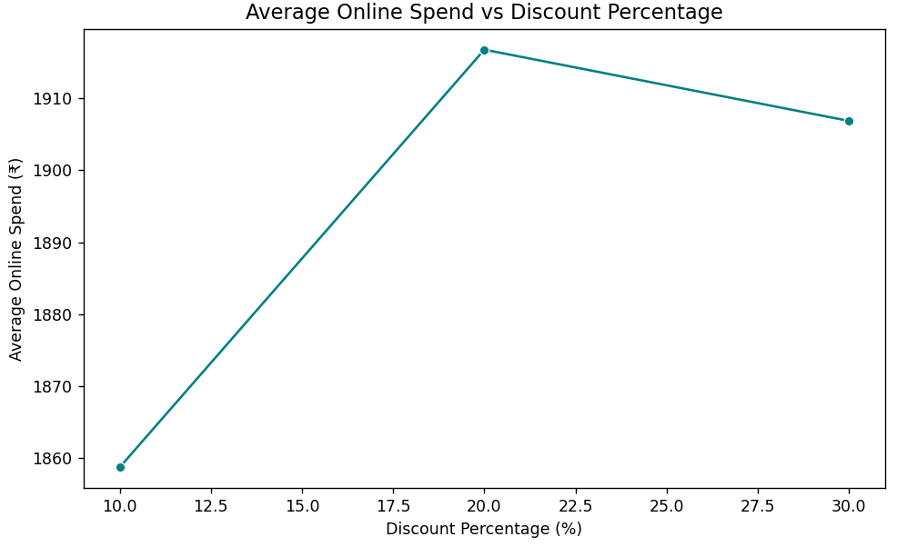
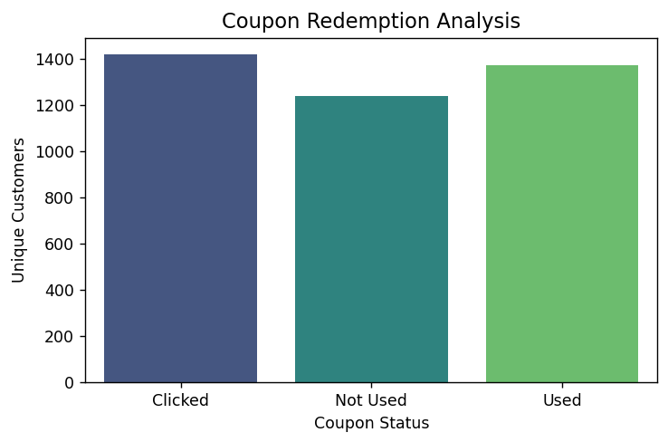
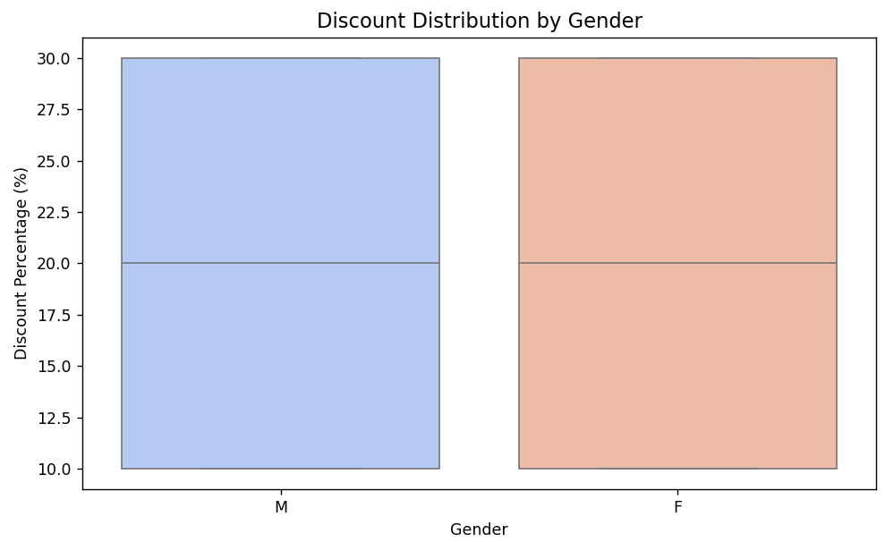
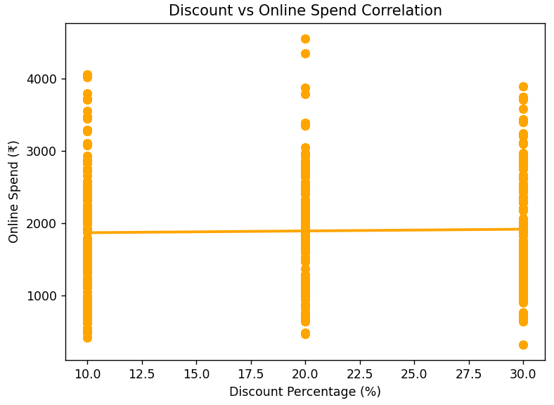
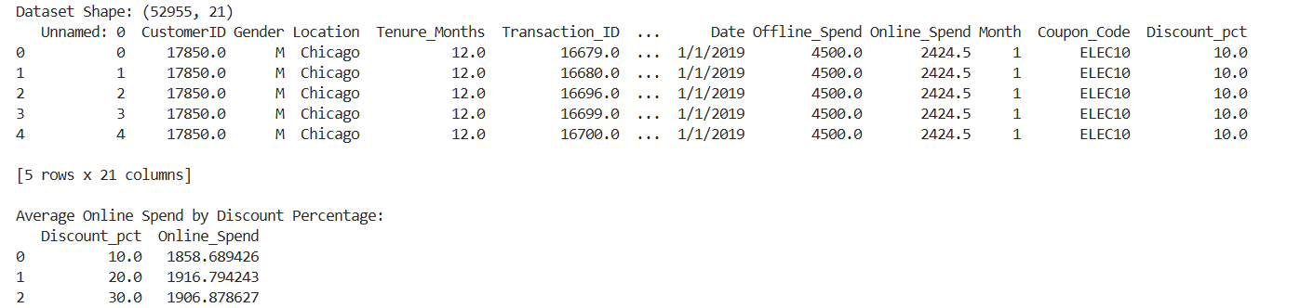
LEARNING OUTCOMES-

PROGRAM NO.-09
AIM-
Discount targeting in online shopping
PROBLEM STATEMENT-
Understanding probability distributions and sampling is essential for data analysis, as they form the foundation of statistical inference and hypothesis testing.
In this practical, we explore how to generate random samples, analyze their distributions, and visualize probability models such as Normal, Binomial, and Poisson distributions using R.
THEORY-
1. Sampling: Sampling is the process of selecting a subset of data from a larger population for analysis.
Types of sampling include:
- Random Sampling – every element has an equal chance of selection.
- Stratified Sampling – population divided into subgroups (strata).
- Systematic Sampling – selecting every kᵗʰ element from a list.
2. Probability Distributions: A probability distribution describes how probabilities are distributed over values of a random variable.
- Normal Distribution (rnorm()) – bell-shaped, used for continuous data.
- Binomial Distribution (rbinom()) – number of successes in fixed trials.
- Poisson Distribution (rpois()) – counts of events in fixed time/space.
- Uniform Distribution (runif()) – equal probability for all outcomes.
3. Applications:
- Modeling real-world data (e.g., height, errors, customer arrivals).
- Understanding random variation and sample behavior.
- Comparing sample statistics with population parameters.
DATASET DESCRIPTION-
This practical does not use an external dataset.
Instead, data samples are generated using R functions such as rnorm(), rbinom(), rpois(), and runif() to demonstrate different sampling and probability distribution techniques.

CODE-
data <- 1:100
sample_random <- sample(data, 10)
cat("Random Sample:\n")
print(sample_random)

set.seed(123)
norm_data <- rnorm(1000, mean=50, sd=10)
hist(norm_data, main="Normal Distribution", col="lightblue", xlab="Values", border="white")

binom_data <- rbinom(1000, size=10, prob=0.5)
hist(binom_data, main="Binomial Distribution", col="lightgreen", xlab="Successes", border="white")

pois_data <- rpois(1000, lambda=5)
hist(pois_data, main="Poisson Distribution", col="salmon", xlab="Occurrences", border="white")

unif_data <- runif(1000, min=0, max=1)
hist(unif_data, main="Uniform Distribution", col="orange", xlab="Values", border="white")

cat("\nSummary Statistics:\n")
cat("Normal Mean:", mean(norm_data), "SD:", sd(norm_data), "\n")
cat("Binomial Mean:", mean(binom_data), "SD:", sd(binom_data), "\n")
cat("Poisson Mean:", mean(pois_data), "SD:", sd(pois_data), "\n")
cat("Uniform Mean:", mean(unif_data), "SD:", sd(unif_data), "\n")
OUTPUT-
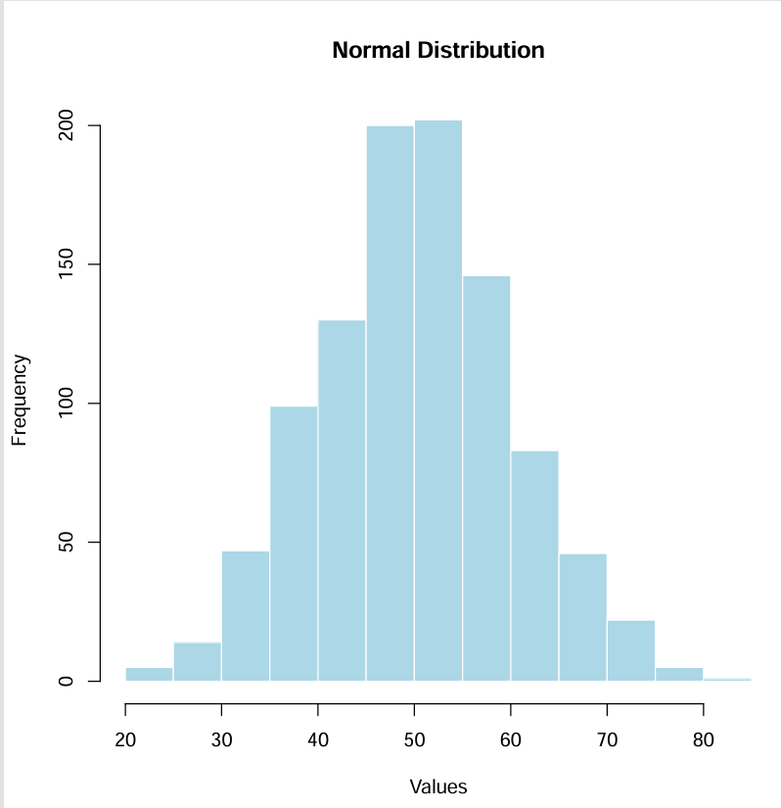
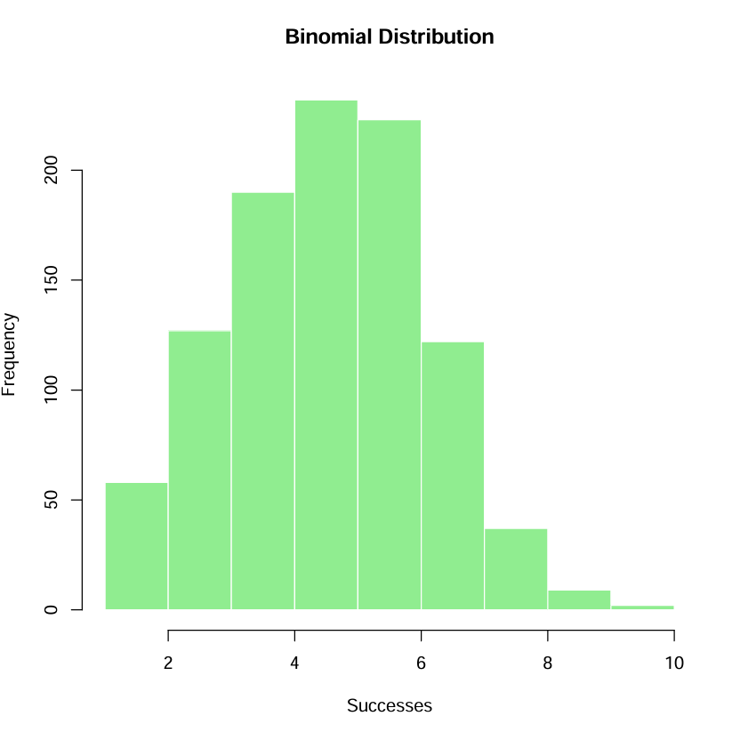
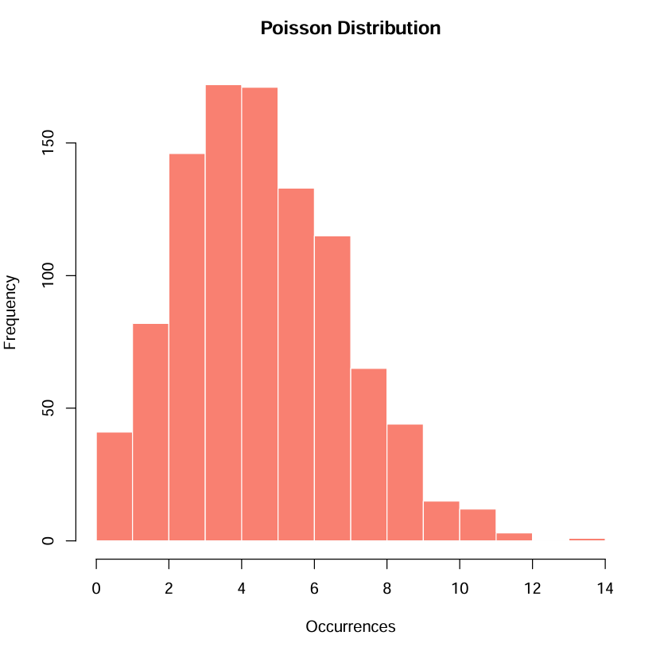
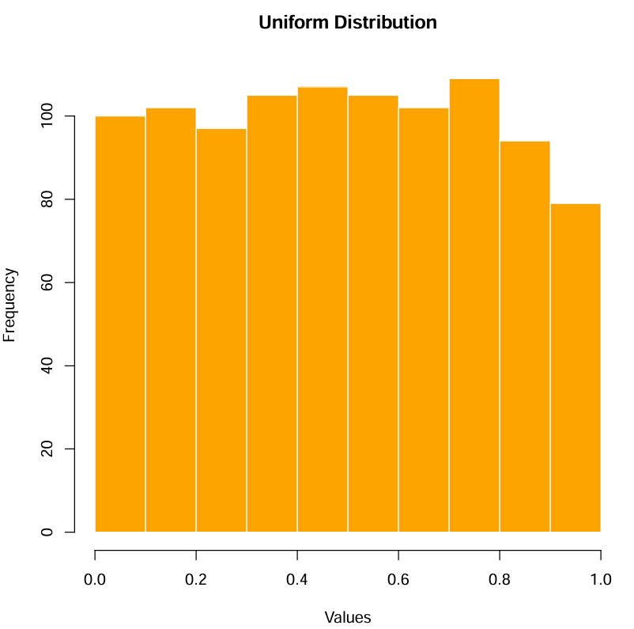
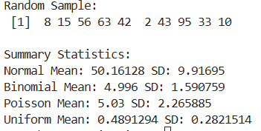
LEARNING OUTCOMES-

PROGRAM NO.-10
AIM-
Hypothesis tests using R
PROBLEM STATEMENT-
In real-world data analysis, we often need to verify whether observed data supports or rejects a certain assumption about a population parameter — for example, whether two groups have the same mean or whether two categorical variables are independent.
This practical focuses on conducting parametric and non-parametric hypothesis tests using R and interpreting the results through p-values and confidence levels.
THEORY-
1. Hypothesis Testing Concepts
- Null Hypothesis (H₀): The assumption that there is no significant difference or effect.
- Alternative Hypothesis (H₁): The assumption that there is a significant difference or effect.
- Significance Level (α): Usually 0.05; it represents the probability of rejecting a true null hypothesis.
- p-value: If p-value < α, we reject H₀ (the result is statistically significant).
2. Common Hypothesis Tests in R
- One Sample t-test (t.test()): Tests if the sample mean differs from a given value.
- Two Sample t-test: Compares means of two independent samples.
- Paired t-test: Compares means from the same group at different times.
- Chi-Square Test (chisq.test()): Tests the relationship between two categorical variables.
- ANOVA (aov()): Tests whether the means of three or more groups are significantly different.
3. Applications
- Testing claims about population means or proportions.
- Comparing performance between two or more groups.
- Checking the association between categorical variables.
DATASET DESCRIPTION-
No external dataset is required for this experiment.
R provides built-in datasets (like mtcars, iris, ToothGrowth, etc.) which can be used for demonstration.
For example:
- mtcars dataset → numerical data for testing differences in mean MPG between groups.
- iris dataset → used for ANOVA to compare species-based feature means.
CODE-
data <- 1:100
sample_random <- sample(data, 10)
cat("Random Sample:\n")
print(sample_random)

set.seed(123)
norm_data <- rnorm(1000, mean=50, sd=10)
hist(norm_data, main="Normal Distribution", col="lightblue", xlab="Values", border="white")

binom_data <- rbinom(1000, size=10, prob=0.5)
hist(binom_data, main="Binomial Distribution", col="lightgreen", xlab="Successes", border="white")

pois_data <- rpois(1000, lambda=5)
hist(pois_data, main="Poisson Distribution", col="salmon", xlab="Occurrences", border="white")

unif_data <- runif(1000, min=0, max=1)
hist(unif_data, main="Uniform Distribution", col="orange", xlab="Values", border="white")

cat("\nSummary Statistics:\n")
cat("Normal Mean:", mean(norm_data), "SD:", sd(norm_data), "\n")
cat("Binomial Mean:", mean(binom_data), "SD:", sd(binom_data), "\n")
cat("Poisson Mean:", mean(pois_data), "SD:", sd(pois_data), "\n")
cat("Uniform Mean:", mean(unif_data), "SD:", sd(unif_data), "\n")

OUTPUT-
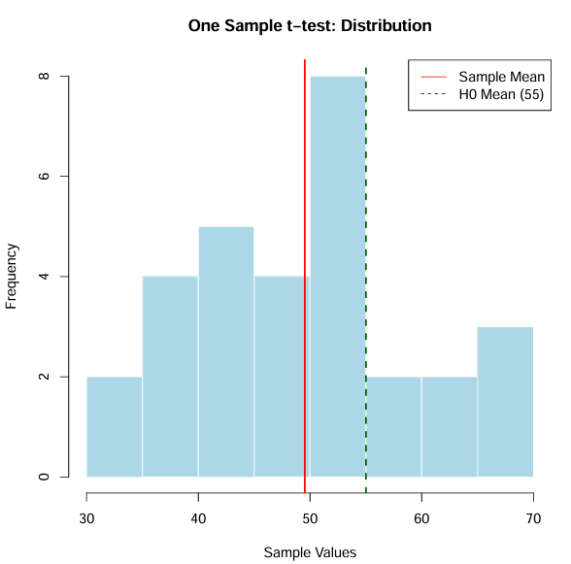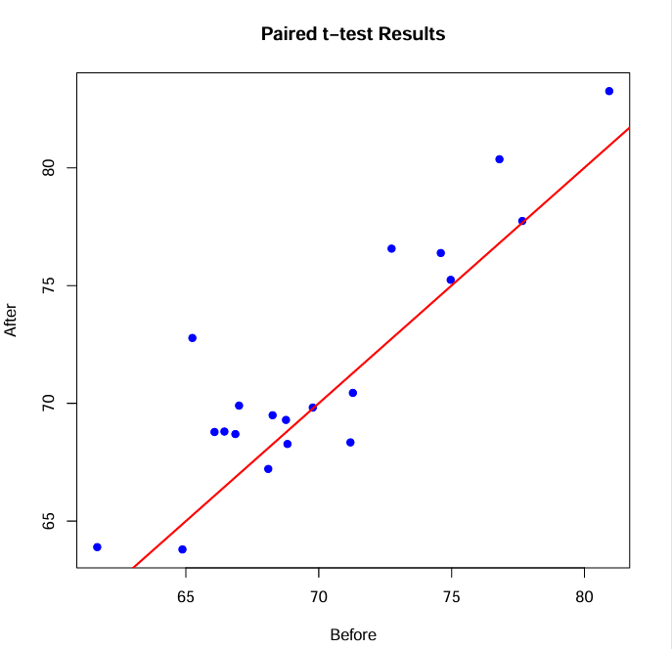
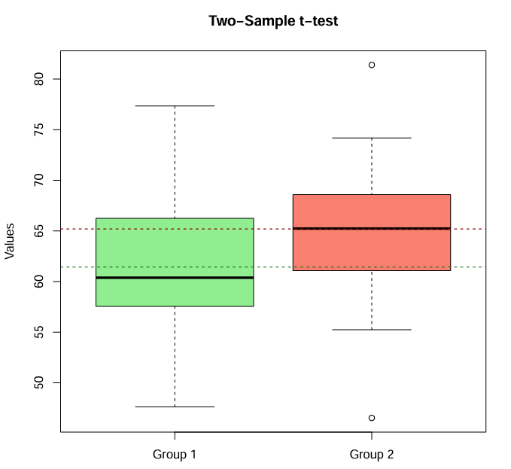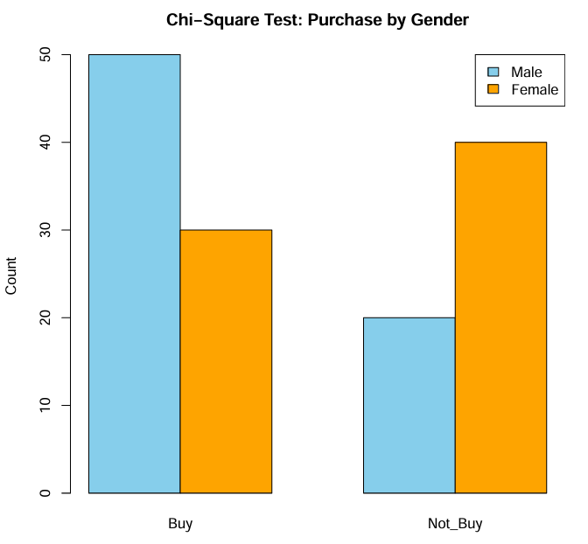
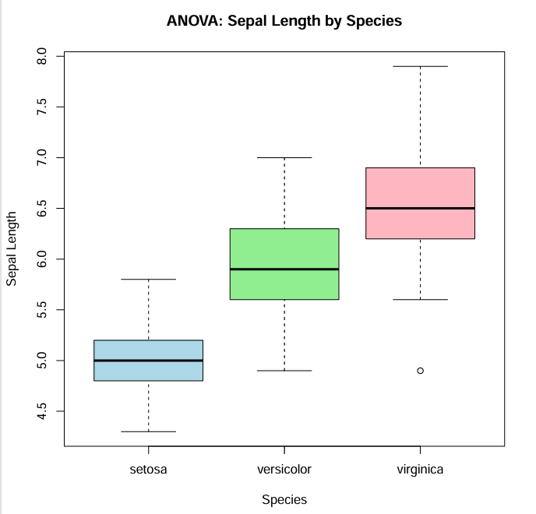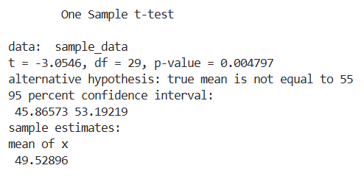
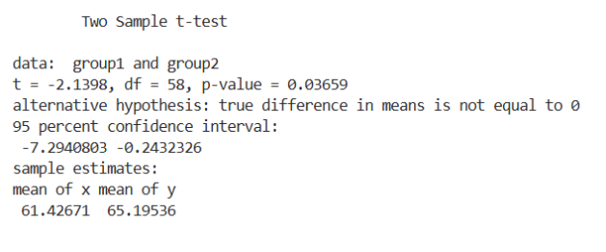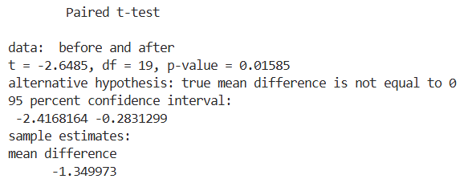
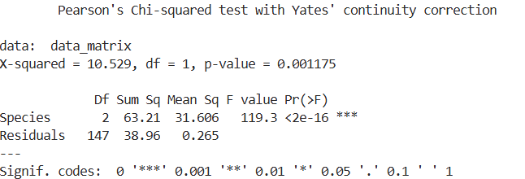

LEARNING OUTCOMES-

